Mar 12, 2026 | Xianghui Regular Checking
Attendees: margretmeng1020@gmail.comJionghao Lin

Notes

For https://sentence-labeling-web.pages.dev/user/normal/manual

Screenshot | Question | Response (Xianghui)
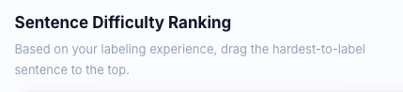 | Use black color for the words below the title “sentence difficulty ranking”  About wording, do you mean, “drag the hardest to easiest” ?
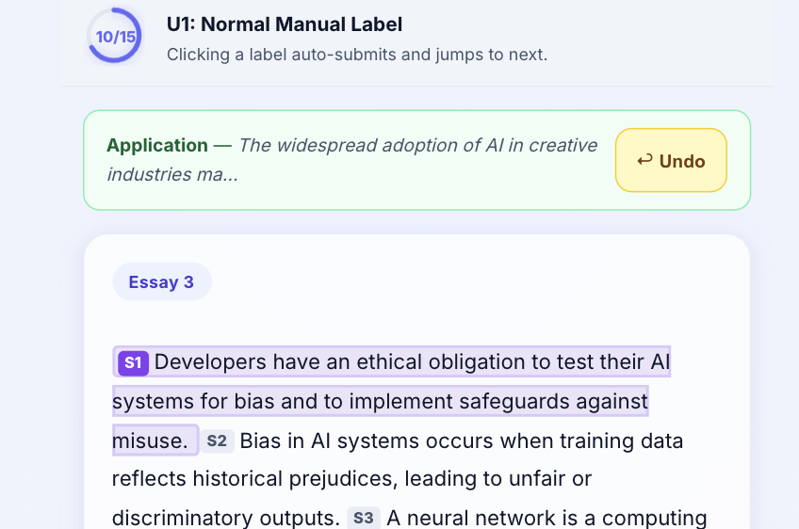 | After finishing ranking, the system direct me to here, but I would like to get back to the ranking page, seems that there is no previous page button?
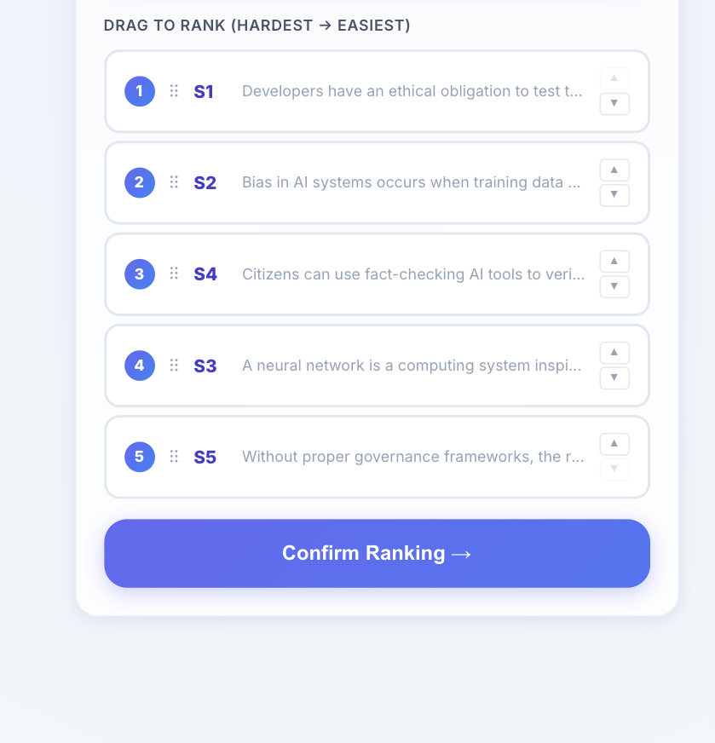 | Also, at ranking page, if I would like to change the label in the previous step, i could not get back
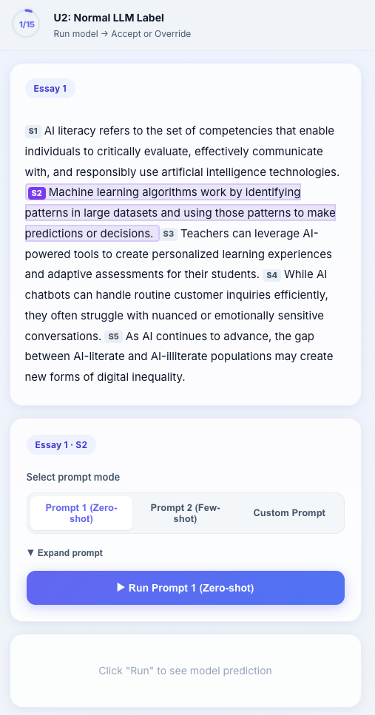 | I use prompt 1 annotated the first sentence (S1), but i’m also curious about the prompt 2 on the first sentence (S1).  The current feature seems automatically moving to the next sentence
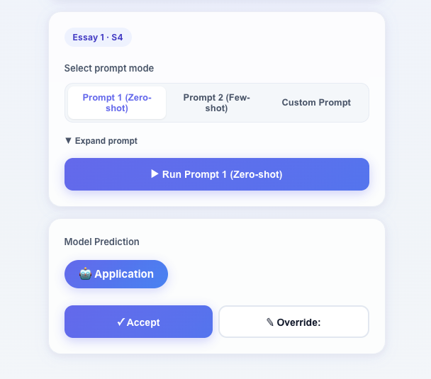 | To save the token, we can indicate “you have 2 attempts left”, every time user run the prompt, the remained number of attempts gets reduce
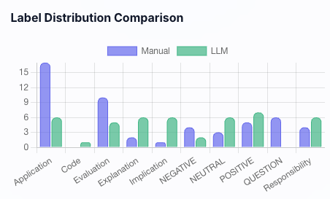 | Add x and y labels  E.g.,  Y label, “frequency”
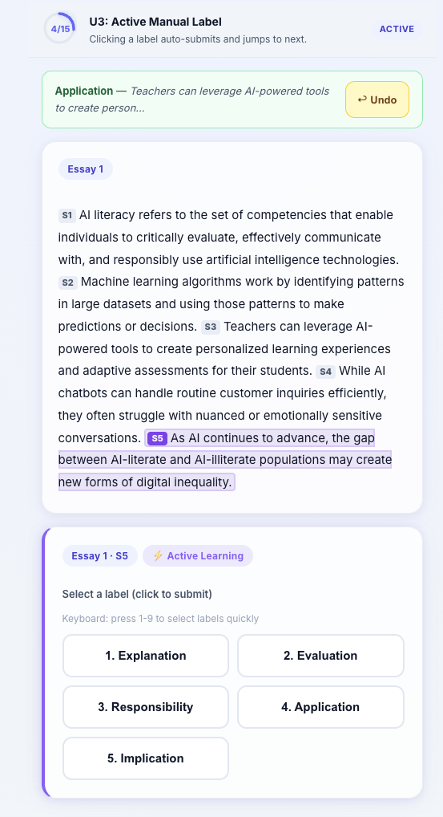 | The active learning version seems showing no difference from the manual and LLM annotation (in terms of UI/UX)  We can indicate label  Easy/Medium/Hard?  Based on Entropy or other measures, the labels can be prepared?
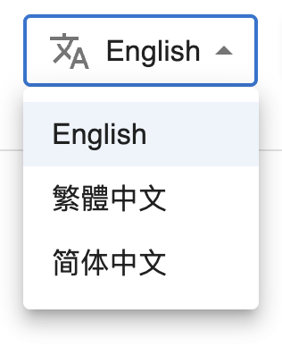 | Can we add the symbol  Additionally double check the drop down menu of our current annotation tool

